**PREDICTING EXPORTS OF DIFFERENT STATES**

**REPORT**

**Submitted to SMARTBRIDGE EDUCATIONAL SERVICES PVT. LTD.**

**IN**

**ELECTRONICS AND COMMUNICATION ENGINEERING**

**BY**

**SHAIK EHETESHAM**





**DEPARTMENT OF ELECTRONICS AND COOMUNICATION ENGINEERING**

**MUFFAKHAM JAH COLLEGE OF ENGINEERING & TECHNOLGY**

**CERTIFICATE**

This is to certify that Shaik Ehetesham, enrolled in the B.E degree programme (Electronics and Communication Engineering)of the Muffakham Jah College of Engineering & Technology, Hyderabad has successfully completed the four week internship cum hands-on training program conducted by Smartbridge Educational services at Stanley College of Engineering and Technology For Women, Abids in ‘Machine Learning using Python 3’ during the time period from 3rd June 2019 to 2nd July 2019 under the guidance of Ms. Pradeepthi, Machine Learning Developer. During this period of internship with us he was found punctual, hardworking and inquisitive.

**_____________________ _____________________**

Mentor Supervisor

**INDEX**

**Content**

1. Predicting exports of different states

1.1 Introduction

* 1. Objectives of Research
  2. Problem Statement
  3. Industry Profile

2. Review of Literature

3. Data Collection

4. Methodology

4.1 Exploratory Data Analysis

4.1.1 (Figures & Tables)

4.1.2 (Figures & Tables)

4.1.3 (Figures & Tables)

4.1.4 (Figures & Tables)

5. Findings and Suggestions

6. Conclusion

7. Bibliography and Reference**INTRODUCTION**

An **export** in [international trade](https://en.wikipedia.org/wiki/International_trade) is a [good](https://en.wikipedia.org/wiki/Goods) or [service](https://en.wikipedia.org/wiki/Service_(business)) produced in one country that is bought by someone in another country. The seller of such goods and services is an *exporter*; the foreign buyer is an *importer*.

Export of goods often requires involvement of [customs](https://en.wikipedia.org/wiki/Customs) authorities. An export's reverse counterpart is an [import](https://en.wikipedia.org/wiki/Import).

### **Exporting**

Many manufacturing firms began their global expansion as exporters and only later switched to another mode for serving a foreign market. Exporting refers to sending of goods and services from the home country to foreign country.

### **Process**

Methods of exporting a product or good or information include mail, hand delivery, air shipping, shipping by vessel, uploading to an internet site, or downloading from an internet site. Exports also include distribution of information sent as email, an email attachment, fax or in a telephone conversation.

### **Barriers**

[Trade barriers](https://en.wikipedia.org/wiki/Trade_barrier) are government laws, [regulations](https://en.wikipedia.org/wiki/Regulation), [policy](https://en.wikipedia.org/wiki/Policies), or practices that either protect domestic products from foreign competition or artificially [stimulate](https://en.wikipedia.org/wiki/Stimulate) exports of particular domestic products. While restrictive business practices sometimes have a similar effect, they are not usually regarded as trade barriers. The most common foreign trade barriers are government-imposed measures and policies that restrict, prevent, or impede the international exchange of goods and services.

### **Strategic**

International agreements limit trade in and the transfer of, certain types of goods and information e.g. goods associated with weapons of mass destruction, advanced telecommunications, arms and torture, and also some art and [archaeological artefacts](https://en.wikipedia.org/wiki/Archaeological_artefact). For example:

* [Nuclear Suppliers Group](https://en.wikipedia.org/wiki/Nuclear_Suppliers_Group) limits trade in nuclear weapons and associated goods (45 countries participate).
* The [Australia Group](https://en.wikipedia.org/wiki/Australia_Group) limits trade in chemical & biological weapons and associated goods (39 countries).
* [Missile Technology Control Regime](https://en.wikipedia.org/wiki/Missile_Technology_Control_Regime) limits trade in the means of delivering weapons of mass destruction (35 countries)
* The [Wassenaar Arrangement](https://en.wikipedia.org/wiki/Wassenaar_Arrangement) limits trade in conventional arms and technological developments (40 countries).

### **Tariffs**

A [tariff](https://en.wikipedia.org/wiki/Tariff) is a tax placed on a specific good or set of goods exported from or imported to a country, creating an economic barrier to trade.  
Usually the tactic is used when a country's domestic output of the good is falling and imports from foreign competitors are rising, particularly if the country has strategic reasons to retain a domestic [production](https://en.wikipedia.org/wiki/Production_(economics)) capability.   
Some failing industries receive a protection with an effect similar to [subsidies](https://en.wikipedia.org/wiki/Subsidies); tariffs reduce the industry's incentives to produce goods quicker, cheaper, and more efficiently. The third reason for a tariff involves addressing the issue of [dumping](https://en.wikipedia.org/wiki/Dumping_(pricing_policy)). Dumping involves a country producing highly excessive amounts of goods and *dumping* the goods on another country at prices that are "too low", for example, pricing the good lower in the export market than in the domestic market of the country of origin. In dumping the producer sells the product at a price that returns no profit, or even amounts to a loss.[[5]](https://en.wikipedia.org/wiki/Export#cite_note-tariff-5) The purpose and expected outcome of a tariff is to encourage spending on domestic goods and services rather than imports.

Tariffs can create tension between countries. Examples include the [United States steel tariff of 2002](https://en.wikipedia.org/wiki/United_States_steel_tariff_2002) and when China placed a 14% tariff on imported auto parts. Such tariffs usually lead to a complaint with the [World Trade Organization](https://en.wikipedia.org/wiki/World_Trade_Organization) (WTO).[[6]](https://en.wikipedia.org/wiki/Export#cite_note-WTO-6) If that fails, the country may put a tariff of its own against the other nation in retaliation, and to increase pressure to remove the tariff.

[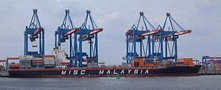](https://en.wikipedia.org/wiki/File:Hamburg.CTA.Altenwerder.BungaRaya.wmt.jpg)

Vessel at Altenwerder Container Terminal (Hamburg)

#### **Advantages of exporting**

* Exporting has two distinct advantages. First, it avoids the often substantial cost of establishing manufacturing operations in the host country.
* Second, exporting may help a company achieve [experience curve effects](https://en.wikipedia.org/wiki/Experience_curve_effects) and [location economies](https://en.wikipedia.org/wiki/Economics_of_location).

Ownership advantages are the firm's specific [assets](https://en.wikipedia.org/wiki/Asset), international experience, and the ability to develop either [low-cost](https://en.wikipedia.org/wiki/Porter_generic_strategies#Cost_Leadership_Strategy) or [differentiated products](https://en.wikipedia.org/wiki/Porter_generic_strategies#Differentiation_Strategy) within the contacts of its [value chain](https://en.wikipedia.org/wiki/Value_chain). The locational advantages of a particular market are a combination of [market potential](https://en.wikipedia.org/wiki/Gap_analysis#Market_potential) and [investment risk](https://en.wikipedia.org/wiki/Financial_risk). [Internationalization](https://en.wikipedia.org/wiki/Internationalization) advantages are the benefits of retaining a [core competence](https://en.wikipedia.org/wiki/Core_competence) within the company and threading it though the value chain rather than to [license](https://en.wikipedia.org/wiki/License), [outsource](https://en.wikipedia.org/wiki/Outsource), or sell it.

In relation to the [eclectic paradigm](https://en.wikipedia.org/wiki/Eclectic_paradigm), companies that have low levels of ownership advantages do not enter foreign markets. If the company and its products are equipped with *ownership advantage* and *internalization advantage*, they enter through low-risk modes such as exporting. Exporting requires significantly lower level of investment than other modes of international expansion, such as [FDI](https://en.wikipedia.org/wiki/Foreign_direct_investment). The lower risk of export typically results in a lower [rate of return](https://en.wikipedia.org/wiki/Rate_of_return) on sales than possible though other modes of [international business](https://en.wikipedia.org/wiki/International_business). In other words, the usual return on export sales may not be tremendous, but neither is the risk. Exporting allows managers to exercise operation control but does not provide them the option to exercise as much marketing control. An exporter usually resides far from the end consumer and often enlists various intermediaries to manage [marketing activities](https://en.wikipedia.org/wiki/Marketing_management). After two straight months of contraction, exports from India rose by 11.64% at $25.83 billion in July 2013 against $23.14 billion in the same month of the previous year.

#### **Disadvantages of exporting**

**Exporting has a number of drawbacks:**

* Exporting from the firm's home base may not be appropriate if lower-cost locations for manufacturing the product can be found abroad. It may be preferable to manufacture where conditions are most favorable to value creation, and to export to the rest of the world from that location.
* A second drawback to exporting, is that high transport cost can make exporting uneconomical, particularly for bulk products. One way to fix this, is to manufacture bulk products regionally.
* Another drawback, is that high tariff barriers can make exporting uneconomical and very risky.

For [small and medium enterprises](https://en.wikipedia.org/wiki/Small_and_medium_enterprises) (SMEs) with fewer than 250 employees, selling goods and services to foreign markets can be more difficult than serving the domestic market. The lack of knowledge of [trade regulations](https://en.wikipedia.org/wiki/Trade_regulation), cultural differences, different languages and [foreign-exchange](https://en.wikipedia.org/wiki/Foreign_exchange_market) situations, as well as the strain of resources and staff, interact like a block for exporting. Indeed, there are some SMEs which are exporting, but nearly two-thirds of them sell to only one foreign market.

### **Export motivations and perceptions**

Motivational factors are "all those factors triggering the decision of the firm to initiate and develop export activities". In the literature, export barriers are divided into four large categories: motivational, informational, operational/resource-based, and knowledge. In addition, export motivators are divided into five dimensions; reactive, marketing,export, technological, external. Research shows that exporters are more favourable to motivators than non-exporters.

exporting may be valuable for economies based on bringing in wealth from other nations reaching beyond the domestic economy and its limits, this can offer it a advantage from trading with nations with more valuable currencies.

**REVIEW OF LITERATURE**

Machine learning is the scientific study of algorithms and statistical models that computer systems use in order to perform a specific task effectively without using explicit instructions, relying on patterns and inference instead. It is seen as a subset of artificial intelligence

There are various **stages of machine learning**:

* Data collection
* Data sorting
* Data analysis
* Algorithm development
* Checking algorithm generated
* The use of an algorithm to further conclusions

To look for patterns, various algorithms are used, which are divided into **two groups**:

* Unsupervised learning
* Supervised learning

With **unsupervised learning**, your machine receives only a set of input data. Thereafter, the machine is up to determine the relationship between the entered data and any other hypothetical data. Unlike supervised learning, where the machine is provided with some verification data for learning, independent Unsupervised learning implies that the computer itself will find patterns and relationships between different data sets. Unsupervised learning can be further divided into clustering and association.

**Supervised learning** implies the computer ability to recognize elements based on the provided samples. The computer studies it and develops the ability to recognize new data based on this data. For example, you can train your computer to filter spam messages based on previously received information.

Some **Supervised learning algorithms** include:

* Decision trees
* Support-vector machine
* Naive Bayes classifier
* k-nearest neighbors
* linear regression
* Random forest classification

### **Python libraries you will need:**

### **NumPy**

NumPy is shortened from Numerical Python, it is the most universal and versatile library both for pros and beginners. Using this tool you are up to operate with multi-dimensional arrays and matrices with ease and comfort. Such functions like linear algebra operations and numerical conversions are also available.

### **Pandas**

Pandas is a well-known and high-performance tool for presenting data frames. Using it you can load data from almost any source, calculate various functions and create new parameters, build queries to data using aggregate functions akin to SQL. What is more, there are various matrix transformation functions, a sliding window method and other methods for obtaining information from data. So it’s totally an indispensable thing in the arsenal of a good specialist.

### **Matplotlib**

Matplotlib is a flexible library for creating graphs and visualization. It is powerful but somewhat heavy-weight. At this point, you can skip Matplotlib and use Seaborn to get started (see Seaborn below).

### **Scikit-Learn**

I can say it’s the most well-designed ML package I’ve observed so far. It implements a wide-range of machine-learning algorithms and makes it comfortable to plug them into actual applications. You can use a whole slew of functions here like regression, clustering, model selection, preprocessing, classification and more. So, it’s totally worth learning and using. The great advantage here is the high speed of work. So it’s not surprising why such leading platforms like Spotify, Booking.com, J.P.Morgan are using scikit-learn. uses supervised learning. Supervised learning is where you have input variables (x) and an output variable (Y) and you use an algorithm to learn the mapping function from the input to the output**Y = f(X)**. The goal is to approximate the mapping function so well that when you have new input data (x) that you can predict the output variables (Y) for that data.

techniques of Supervised Machine Learning algorithms include **linear** and **logistic regression**, **multi-linear,classification**, **Decision Trees**  and  **support vector machines**. Supervised learning requires that the data used to train the algorithm is already labeled with correct answers. For example, a classification algorithm will learn to identify animals after being trained on a dataset of images that are properly labeled with the species of the animal and some identifying characteristics.  
Supervised learning problems can be further grouped into **Regression** and **Classification**problems. Both problems have as goal the construction of a succinct model that can predict the value of the dependent attribute from the attribute variables. The difference between the two tasks is the fact that the dependent attribute is numerical for regression and categorical for classification.

**Regression**

A regression problem is when the output variable is a real or continuous value, such as “salary” or “weight”. Many different models can be used, the simplest is the linear regression. It tries to fit data with the best hyper-plane which goes through the points.

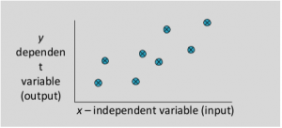

**Types of Regression Models:**

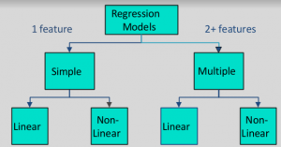

[**Classification**](https://www.geeksforgeeks.org/getting-started-with-classification/)

A classification problem is when the output variable is a category, such as “red” or “blue” or “disease” and “no disease”. A classification model attempts to draw some conclusion from observed values. Given one or more inputs a classification model will try to predict the value of one or more outcomes.  
For example, when filtering emails “spam” or “not spam”, when looking at transaction data, “fraudulent”, or “authorized”. In short Classification either predicts categorical class labels or classifies data (construct a model) based on the training set and the values (class labels) in classifying attributes and uses it in classifying new data. There are a number of classification models. Classification models include logistic regression, decision tree, random forest, gradient-boosted tree, multilayer perceptron, one-vs-rest, and Naive Bayes.

**For example :  
Which of the following is/are classification problem(s)?**

* Predicting the gender of a person by his/her handwriting style
* Predicting house price based on area
* Predicting whether monsoon will be normal next year
* Predict the number of copies a music album will be sold next month

Solution : Predicting the gender of a person Predicting whether monsoon will be normal next year. The other two are regression.

**OBJECTIVES OF RESEARCH**

The main motive of the project, that is, predicting exports of different states is to construct an efficient model for the determination of the export pattern of different food items in different states based on factors such as the quantity of food items produced and food abundance.The building of an accurate model would help in determining the state that has abundance of a particular food item for exportation.

Hence, would help the trade industries to predict the availability of food item efficiently and would save time in searching for the availability of food in other states.

**PROBLEM STATEMENT**

The export of food between different states can be determined from the availability of the required food item in a state.

This can be calculated by the abundance and the quantity of the food being exported.

The issue in the **Predicting Exports of Different States** is to determine which state can export a food item efficiently .

**INDUSTRY PROFILE**

The Project predicting exports of different states deals with the trade industry, since the dataset portrays the quantity of different food items being exported.

**Trade** involves the transfer of [goods or services](https://en.wikipedia.org/wiki/Goods_and_services) from one person or entity to another, often in exchange for [money](https://en.wikipedia.org/wiki/Money). A [system](https://en.wikipedia.org/wiki/System) or network that allows trade is called a [market](https://en.wikipedia.org/wiki/Market_(economics)).

Trade exists due to specialization and the [division of labor](https://en.wikipedia.org/wiki/Division_of_labor), a predominant form of [economic activity](https://en.wikipedia.org/wiki/Economic_activity) in which individuals and groups concentrate on a small aspect of production, but use their output in trades for other products and needs. Trade exists between regions because different regions may have a [comparative advantage](https://en.wikipedia.org/wiki/Comparative_advantage) (perceived or real) in the production of some trade-able [commodity](https://en.wikipedia.org/wiki/Commodity)—including production of natural resources scarce or limited elsewhere, or because different regions' sizes may encourage [mass production](https://en.wikipedia.org/wiki/Mass_production). In such circumstances, trade at [market prices](https://en.wikipedia.org/wiki/Market_price) between locations can benefit bothlocations.



# **10 Rules For Successful Trading:**

### **Rule No.1: Always Use a Trading Plan**

A trading plan is a written set of rules that specifies a trader's entry, exit and [money management](https://www.investopedia.com/terms/m/moneymanagement.asp) criteria. Using a trading plan allows traders to do this, although it is a time-consuming endeavor.

### **Rule No.2: Treat Trading Like a Business**

In order to be successful, one must approach trading as a full- or part-time business - not as a hobby or a job. As a hobby, where no real commitment to learning is made, trading can be very expensive. As a job, it can be frustrating since there is no regular paycheck. Trading is a business and incurs expenses, losses, taxes, uncertainty, stress, and risk. As a trader, you are essentially a [small business](https://www.investopedia.com/university/small-business/)owner and must do your research and strategize to maximize your business's potential.

### **Rule No.3: Use Technology to Your Advantage**

Trading is a competitive business, and it's safe to assume the person sitting on the other side of a trade is taking full advantage of technology. Charting platforms allow traders an infinite variety of methods for viewing and analyzing the markets. Backtesting an idea on historical data prior to risking any cash can save a trading account, not to mention stress and frustration. Getting market updates with smartphones allows us to monitor trades virtually anywhere. Even technology that today we take for granted, like high-speed internet connections, can greatly increase trading performance.

### **Rule No.4: Protect Your Trading Capital**

Saving money to fund a trading account can take a long time and much effort. It can be even more difficult (or impossible) the next time around. It is important to note that protecting your [trading capital](https://www.investopedia.com/terms/c/capital.asp) is not synonymous with not having any losing trades. All traders have losing trades; that is part of the business. Protecting capital entails not taking any unnecessary risks and doing everything you can to preserve your trading business.

### **Rule No.5: Become a Student of the Markets**

Think of it as continuing education - traders need to remain focused on learning more each day. Since many concepts carry prerequisite knowledge, it is important to remember that understanding the markets, and all of their intricacies, is an ongoing, lifelong process.

### **Rule No.6: Risk Only What You Can Afford to Lose**

Rule No.4 mentions that funding a trading account can be a long process. Before a trader begins using real cash, it is imperative that all of the money in the account be truly expendable. If it's not, the trader should keep saving until it is.

### **Rule No.7: Develop a Trading Methodology Based on Facts**

Taking the time to develop a sound trading methodology is worth the effort. It may be tempting to believe in the "so easy it's like printing money" trading scams that are prevalent on the internet. But facts, not emotions or hope, should be the inspiration behind developing a trading plan.

### **Rule No.8: Always Use a Stop Loss**

A [stop loss](https://www.investopedia.com/terms/s/stop-lossorder.asp) is a predetermined amount of risk that a trader is willing to accept with each trade. The stop loss can be either a dollar amount or percentage, but either way it limits the trader's exposure during a trade. Using a stop loss can take some of the emotion out of trading since we know that we will only lose X amount on any given trade.

### **Rule No.9: Know When to Stop Trading**

There are two reasons to stop trading: an ineffective trading plan, and an ineffective trader.

An ineffective trading plan shows much greater losses than anticipated in historical testing. Markets may have changed, volatility within a certain trading instrument may have lessened, or the trading plan simply is not performing as well as expected. One will benefit from remaining unemotional and businesslike. It might be time to reevaluate the trading plan and make a few changes or to start over with a new trading plan. An unsuccessful trading plan is a problem that needs to be solved. It is not necessarily the end of the trading business.

### **Rule No.10: Keep Trading in Perspective**

It is important to stay focused on the big picture when trading. A losing trade should not surprise us - it is a part of trading. Likewise, a winning trade is just one step along the path to profitable trading. It is the cumulative profits that make a difference. Once a trader accepts wins and losses as part of the business, emotions will have less of an effect on trading performance. That is not to say that we cannot be excited about a particularly fruitful trade, but we must keep in mind that a losing trade is not far off.

**Data Collection**

The name of the dataset is “exports.csv” which is of the format .csv i.e. Comma Separated Values. The dataset is read into python using read_csv function of pandas package. Before reading file into python, other important packages are imported like numpy (for operations on numeric data), pandas (for data manipulation), matplotlib.pyplot (for data visualization), sklearn ( an important package including all the algorithms for machine learning,seaborn for better visualization of data and to get a graphical idea about the given dataset using graphs.

Once the data is read, It is clear that there are 11 features in which there is 1 predictor .

The features are the following:

1. Beef
2. Pork
3. Poultry
4. Diary
5. Fruits fresh
6. Fruits proc
7. Veggies fresh
8. Veggies proc
9. Corn
10. Wheat
11. Cotton

The predictor is : Total Exports.

There is one target: Dataset which is to be predicted using various machine learning models.

Based on the dataset and observation we can use two models which are Multi-linear Regression and Decision tree regressor.

**4.Methodology**

**Exploratory data Analysis :**

1. **Data Collection:** Firstly, we have collected the dataset using Internet as a resource and have selected the dataset which is based on the exports between different states.The data has 11 features excluding the code of the states, names of the states, category and the Total exports.
2. **Data Cleaning:** Secondly, we have checked for any NULL values available in the dataset by using the command mentioned below. If we get any NULL values we fill the NULL values by mean, median or mode of that particular column based on the category.

**Command: dataset.isnull().any()**

Upon executing the above command we didn’t get any NULL values in our dataset.

**3.Data Reduction:** Here we are reducing the unwanted data based on our requirement. In our dataset we have dropped the columns:fresh fruits,fruits proc,veggies fresh and veggies proc as we are considering the total of each of this entities.we have used the following command to drop the columns.

**Command: dataset.drop(drop,inplace=True,axis=1)**

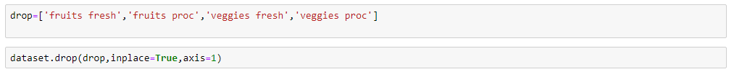

**BEFORE DATA REDUCTION**

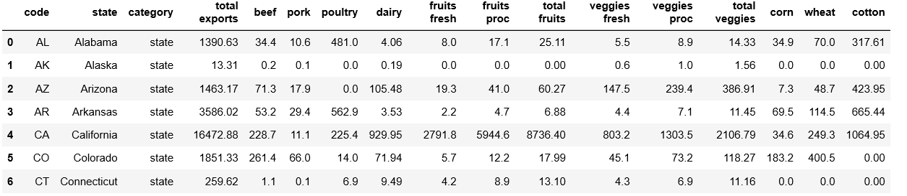

**AFTER DATA REDUCTION**

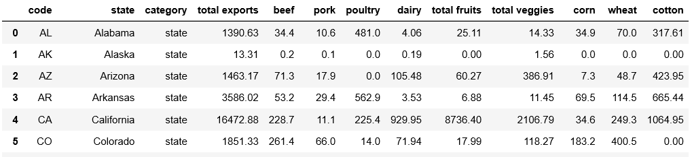

**VISUALIZATION OF DATA:**

1. **Heat Map :**

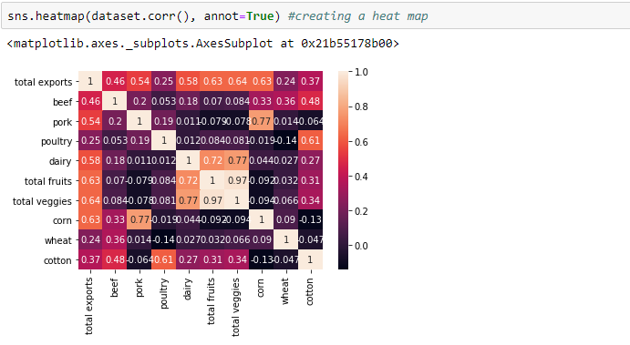

**INFERENCE**: Heat maps are graphical representation of data that utilize color coded systems. The primary purpose of heat maps is to better visualize the volume of location or events within a dataset and assist in directing viewers towards areas on data visualizations that matter most.

**MULTI LINEAR REGRESSION PLOTTING:**

**1.Plotting between Dairy and Total exports :**

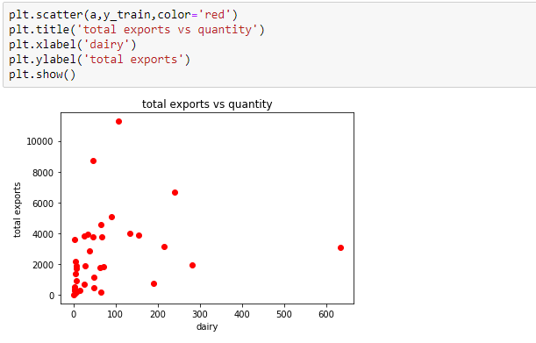

**INFERENCE**:It is the plot between Dairy and Total exports .Here Dairy is independent variable and Total exports Is dependent variable. The red dots are representing the relation between the export of dairy and the total exports.

1. **Plotting between Beef and Total exports:**

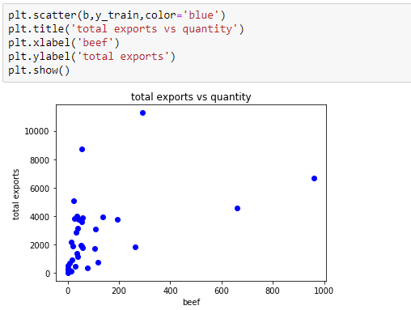

**INFERENCE**:It is the plot between Beef and Total exports.Here Beef is independent variable and Total exports Is dependent variable.The blue dots are representing the relation between the export of beef and the total exports.

**3**.**Plotting between Pork and Total Exports:**

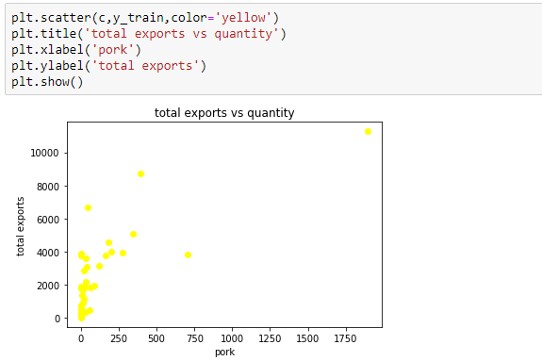

**INFERENCE**:It is the plot between Pork and Total exports.Here Pork is independent variable and Total exports Is dependent variable.The yellow dots are representing the relation between the export of poultry and the total exports.

**4.Plotting between Poultry and Total exports**:

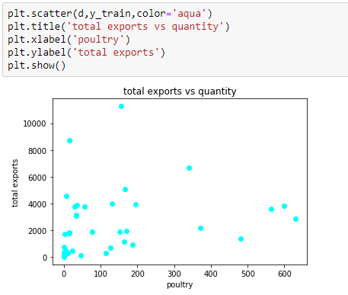

**INFERENCE**:It is the plot between Poultry and Total exports.Here Poultry is independent variable and Total exports Is dependent variable.The aqua dots are representing the relation between the export of poultry and the total exports.

1. **Plotting between Total veggies and Total Exports:**

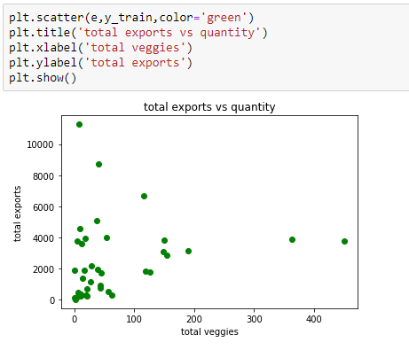

**INFERENCE**:It is the plot between Total Veggies and Total exports.Here Total veggies is independent variable and Total exports Is dependent variable.The green dots are representing the relation between the export of Total veggies and the total exports.

**6.Plotting between Total fruits and Total Exports:**

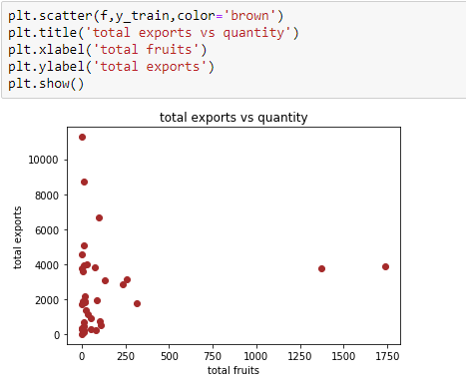

**INFERENCE**:It is the plot between Total Fruits and Total exports.Here Total Fruits is independent variable and Total exports Is dependent variable.The brown dots are representing the relation between the export of dairy and the total exports.

1. **Plotting between Corn and Total Exports:**

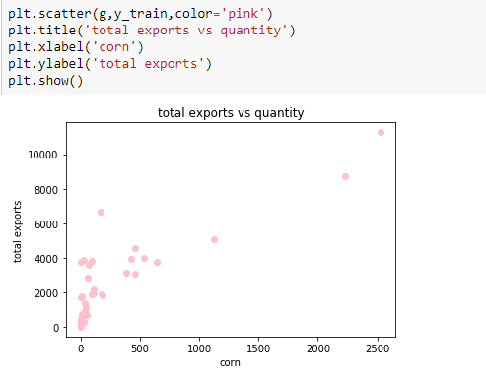

**INFERENCE**:It is the plot between Corn and Total exports.Here Corn is independent variable and Total exports Is dependent variable.The Pink dots are representing the relation between the export of Corn and the total exports.

**8.Plotting between Wheat and Total Exports:**

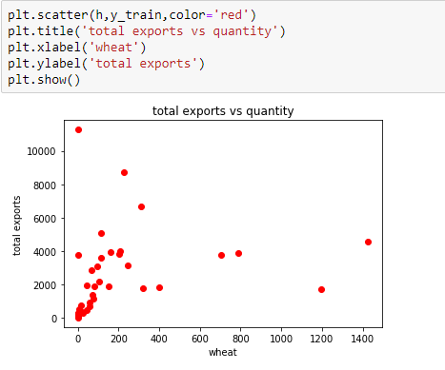

**INFERENCE**:It is the plot between wheat and Total exports.Here wheat is independent variable and Total exports Is dependent variable.The red dots are representing the relation between the export of wheat and the total exports.

**9.Plotting between Cotton and Total Exports:**

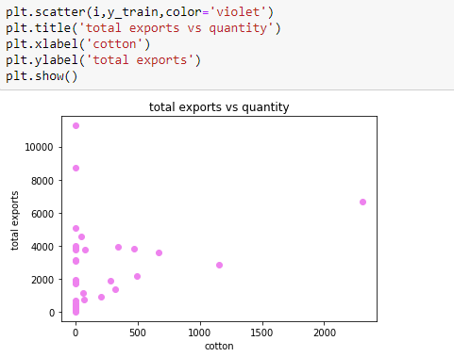

**INFERENCE**:It is the plot between cotton and Total exports.Here cotton is independent variable and Total exports Is dependent variable.The red dots are representing the relation between the export of cotton and the total exports.

**BOX PLOTTING :**

1. **Plotting between Beef and Total exports:**

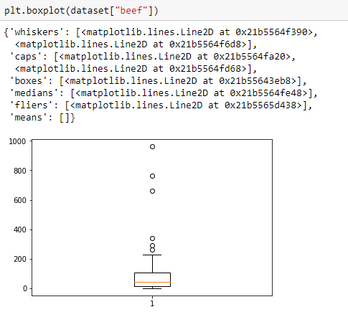

INFERENCE: Box Plot is often used in explanatory data analysis. This type of data is used to show the shape of distribution, its central value and its variability. It consists of minimum,first quartile,median,third quartile and maximum.

1. **Plotting between Pork and Total exports:**

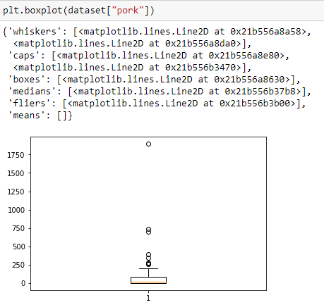

INFERENCE: Box Plot is often used in explanatory data analysis. This type of data is used to show the shape of distribution, its central value and its variability. It consists of minimum,first quartile,median,third quartile and maximum.

1. **Plotting between poultry and total exports**

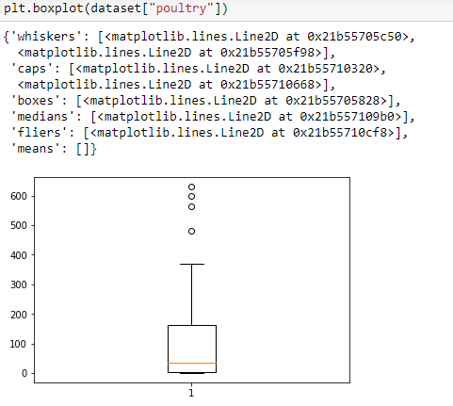

INFERENCE: Box Plot is often used in explanatory data analysis. This type of data is used to show the shape of distribution, its central value and its variability. It consists of minimum,first quartile,median,third quartile and maximum.

**4.Plotting between dairy and total exports :**

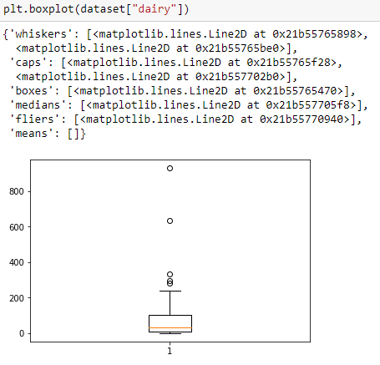

INFERENCE: Box Plot is often used in explanatory data analysis. This type of data is used to show the shape of distribution, its central value and its variability. It consists of minimum,first quartile,median,third quartile and maximum.

**5.Plotting between total fruits and total exports:**

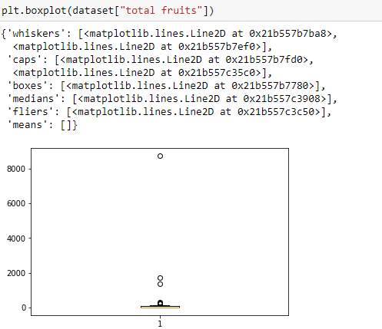

INFERENCE: Box Plot is often used in explanatory data analysis. This type of data is used to show the shape of distribution, its central value and its variability. It consists of minimum, first quartile, median, third quartile and maximum.

**6. Plotting between total veggies and total exports:**

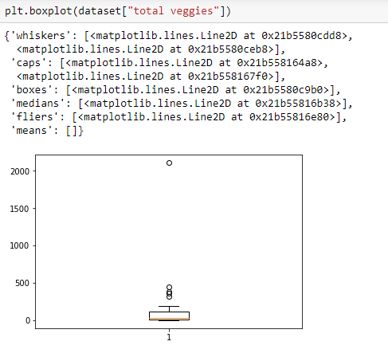

INFERENCE: Box Plot is often used in explanatory data analysis. This type of data is used to show the shape of distribution, its central value and its variability. It consists of minimum,first quartile,median,third quartile and maximum.

**7.Plotting between corn and total exports:**

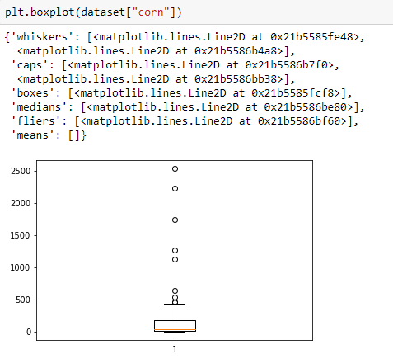

INFERENCE: Box Plot is often used in explanatory data analysis. This type of data is used to show the shape of distribution, its central value and its variability. It consists of minimum,first quartile,median,third quartile and maximum.

**8.Plotting between wheat and total exports:**

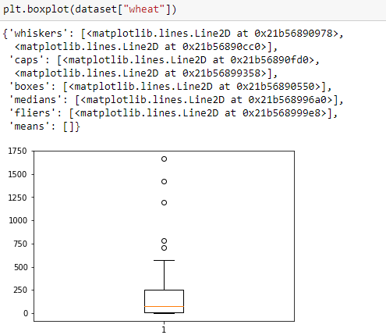

INFERENCE: Box Plot is often used in explanatory data analysis. This type of data is used to show the shape of distribution, its central value and its variability. It consists of minimum,first quartile,median,third quartile and maximum.

**9.Plotting between cotton and Total exports:**

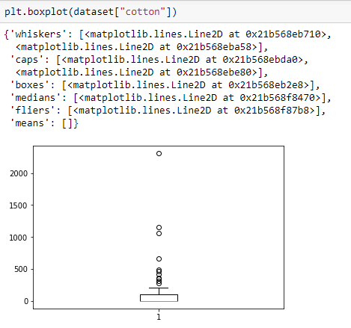

INFERENCE: Box Plot is often used in explanatory data analysis. This type of data is used to show the shape of distribution, its central value and its variability. It consists of minimum,first quartile,median,third quartile and maximum.

**Findings and suggestions**

From this project we have predicted the exports of different states based on the exports of different entities.

The heat map is to better visualize the volume of location or events within a dataset and assist in directing viewers towards areas on data visualizations that matter most. Multi linear regression plot shows the relation between the total exports and each of the individual entities. Box Plot is used to show the shape of distribution, its central value and its variability. It consists of minimum, first quartile, median, third quartile and maximum of each of the individual entities like beef, pork, poultry, dairy, total fruits, total veggies, corn, wheat and cotton.

We can infer that the states which don’t export certain entities, can import it from the other states. The states which produce excessive quantity of certain entity, can export it to the other states. This builds a healthy and strong relationships between the states.

**Modelling**

**Metrics for all the models with will the features**

|  |  |  |
| --- | --- | --- |
| **S.No.** | **Models** | **Accuracy** |
| 1. | Multi Linear Regression | 97.2% |
| 2. | Linear Regression | -27.33% |
| 3. | Decision Tree Regression | 28.5% |

**CONCLUSION**

It is concluded that based on the items exported by different states, we can predict the total exports of each individual states. Our best fit model is Multi Linear Regression model as the accuracy is 97%. The organization significantly influences the marketing behaviour of exporters. And experience of the organization affect the marketing behaviour within certain size stages beyond that it has insignificant influence.